The study of the temperature dependence of the vapor elasticity of an individual substance by the dynamic method.

The theoretical part
Vaporization (evaporation) of a liquid substance is one of the main processes of phase transitions and is characterized by the heat of vaporization (evaporation). The heat of vaporization is the amount of heat that must be communicated to a certain amount of a substance at a constant temperature and pressure in order to transfer it from a liquid state to steam. The study of phase transitions allows us to identify the relationship and interdependence between such parameters as the enthalpy (heat) of the phase transition, pressure, temperature, and also to obtain the dependence of the saturated vapor pressure of a substance on temperature and vice versa. This knowledge is necessary for determining the physical and chemical properties of substances and materials, as well as for performing thermodynamic and technological calculations for various chemical processes.

The second principle of thermodynamics for phase transformations
One of the most important properties of a liquid substance is the pressure of its saturated vapor, which characterizes the ability of a liquid substance to evaporate. The thermal motion of the molecules leads to their separation from the surface of the liquid and transition to the gas phase. However, such a separation can occur if the kinetic energy of the molecule is greater than the energy of mutual coupling with the liquid molecules. Some of the molecules that have broken away from the surface of the liquid subsequently condense again, while the other part remains in the gaseous phase. Thus, two processes always occur simultaneously on the surface of the liquid: evaporation and condensation. If the evaporation and condensation processes are carried out in a closed space, the velocities of these processes are aligned, and a state of dynamic equilibrium occurs between the liquid and gaseous phases. The second principle of thermodynamics allows us to determine in which direction the process will actually proceed, when and under what conditions the state of equilibrium between steam and liquid will be established, and how temperature and pressure affect this state of equilibrium. The mathematical expression of the second law of thermodynamics has the form:

- For reversible processes :𝒅𝑺 = 𝜹𝑸/ 𝑻 (1.1)
- For irreversible processes: 𝒅𝑺 > 𝜹𝑸 /𝑻 (1.2)
where S is a certain state function introduced by Clausius and called entropy. Entropy is an extensive value, i.e. it depends on the amount of matter in the system.
Entropy obeys the law of additivity, i.e. the entropy of an equilibrium thermodynamic system is equal to the sum of the entropy of its individual parts. The change in entropy in a complex process is equal to the sum of the changes in entropy in the individual stages of the process.
Entropy is a function of the state, i.e. its change does not depend on the path of the process (whether it is reversible or irreversible), but is determined by the initial and final state of the system. Therefore, the calculation of the entropy change is based on the relation (1.1) for a reversible process, which should be integrated for the final transformation from state 1 to state 2:
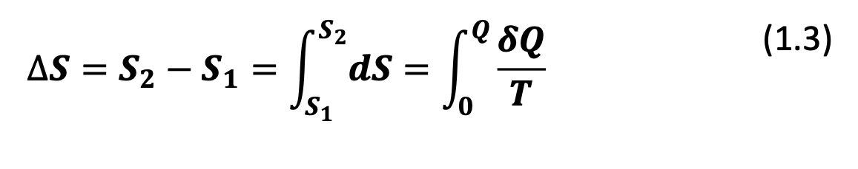
where S1 and S2 are the entropies of the initial and final states, respectively. The processes of phase transformations (melting, evaporation, sublimation, polymorphic transformations, etc.) occur at a constant temperature. The equilibrium conduct of these processes also requires the preservation of constant pressure. Therefore, for an isothermal process (T=const), we obtain:

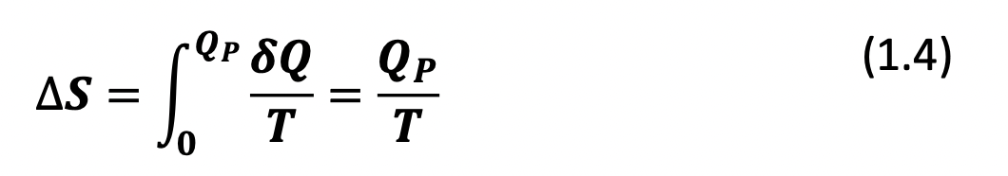

At a constant pressure, 𝑄􏰁 = ∆𝐻ф.п. and then the change in the entropy of the phase transition is
determined by the equation:
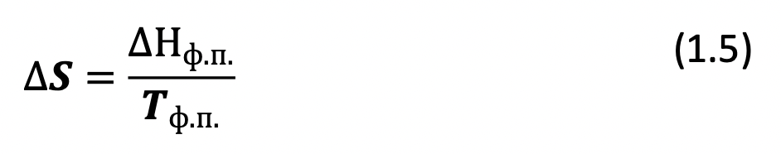
where ∆Nf. p.- the heat of the phase transition; - the absolute temperature of the phase transition.

Phase equilibrium in a single-component system. Diagrams of the state of single-component systems.
The basic law of phase equilibrium, often called the Gibbs phase rule, is one of the important applications of the second law of thermodynamics to the study of the transformation in heterogeneous systems where the possible transitions of a substance from one phase to another (aggregate transformation, the dissolution of the solids, the redistribution of solids between the two solvents, etc.). The ratio is called the Gibbs phase rule:
C=A−F+𝟐 (1.6)
the number of degrees of freedom (C) of an equilibrium thermodynamic system, which is affected only by temperature and pressure, is equal to the number of independent components (K) of the system minus the number of phases (F) plus two. If the equilibrium in the system, in addition to temperature and pressure, can be influenced by other external factors, for example, electric and magnetic fields, the gravitational field, etc., then in equation (1.6) the number of external factors (n) will be more than two:
C=K-F+𝐧 (1.7)

In single-component systems, the phases consist of a single substance (component) in various aggregate states. According to the Gibbs phase rule, at K=1, the number of degrees of freedom will be equal to:
C=𝟏 - F+𝟐=𝟑 – F (1.8)
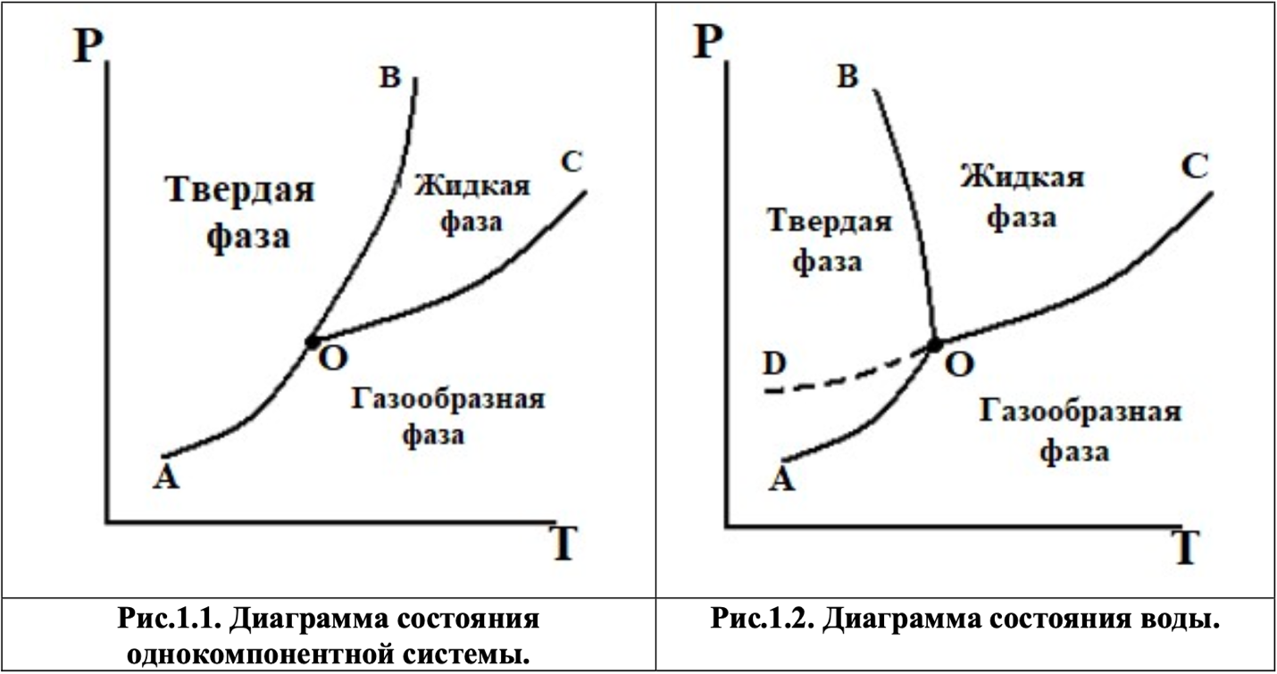

Three curves divide the diagram into fields, each of which corresponds to one aggregate state of matter: solid, liquid and gaseous. The curves correspond to the equilibrium between the corresponding two phases. The OC curve describes the dependence of the saturated vapor pressure over the liquid and is called the evaporation curve; the OВ curve describes the dependence of the melting (freezing) temperature of the liquid on the external pressure and is called the melting curve; The curve OA is the dependence of the pressure of saturated steam over a solid on temperature and is called the sublimation curve, the curve OD determines the pressure of saturated steam over supercooled water (metastable state). The same curves characterize the inverse equilibrium corresponding processes: condensation, crystallization and sublimation.

All the curves in the diagrams can be described using the equation of Clausius - Clapeyron (1.13). In the melting process (curve S, Fig.1.1), the volume of the resulting liquid phase more
the volume of the solid phase ∆𝑉 = 𝑉ж − 𝑉􏰀 > 0 , and the derivative dT/dP > 0, therefore, with the increase of pressure the melting point increases. In Fig.1.2 shows the melting process in which the volume of the solid phase is greater than the volume of the liquid ∆𝑉 = 𝑉ж − 𝑉􏰀 < 0 and the derivative dT/dP< 0, , this means that as the pressure increases, the melting point of the substance decreases (curve OV, Fig. 1. 2). Only a small number of substances have this property, for example, water, bismuth, antimony, cast iron.
Only a small number of substances have this property, for example, water, bismuth, antimony, cast iron. In the evaporation process (the OS curve in Figures 1.1 and 1.2), the derivative dT/dP > 0, so when the pressure increases, the boiling point always increases.
The point O is called a triple point, because it can be in equilibrium at the same time three phases: solid, liquid and gaseous. The number of degrees of freedom at a triple point is equal to C = 3 - F = 3 - 3= 0, which means that none of the parameters can be changed, otherwise the equilibrium state in the system will change. The pressure that the vapor molecules in equilibrium with the liquid phase exert on the walls of the vessel and on the surface of the liquid is called the saturated vapor pressure (for short, the vapor pressure of the liquid). According to the phase rule, a system with one component and two coexisting phases has only one degree of freedom C = 3 -F = 3 - 2 = 1. Therefore, during the evaporation process, one of the parameters (either temperature or pressure) can be changed arbitrarily and the number and nature of the phases will not change. The vapor pressure above the surface of a stable chemical substance (liquid or solid) is determined only by temperature and does not depend on the amount of the substance taken, on the amount of steam and on the presence and concentration of air or other gas inert with respect to another vapor.
The Clapeyron - Clausius equation for the vaporization process
Let us consider the regularities associated with the transformation of one phase of pure matter into another. When there is an equilibrium between the two phases, the condition must be met:
𝒅𝝁(𝟏) = 𝒅𝝁(𝟐) (1.9)
where μ is the chemical potential of the corresponding phase.
For reversible processes, we can write expressions for the chemical potential of one mole of a pure substance in the first and second phases:
𝒅𝝁(𝟏) = −𝑺(𝟏)𝒅𝑻 + 𝑽(𝟏)𝒅R
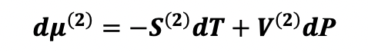(1.10)
Substitute equation (10) into the equilibrium condition (9):
−𝑺(𝟏)𝒅𝑻 + 𝑽(𝟏)𝒅𝑷 = −𝑺(𝟐)𝒅𝑻 + 𝑽(𝟐)𝒅𝑷
Convert the resulting expression:
(𝑺(𝟐) − 𝑺(𝟏))𝒅𝑻 = (𝑽(𝟐) − 𝑽𝟏)𝒅𝑷
𝒅𝑷/dT = (𝑺(𝟐) − 𝑺(𝟏))/ (𝑽(𝟐) − 𝑽𝟏) = = ∆𝑺/∆𝑽 (1.11)
For reversible isothermal transitions
∆ 𝑺 = ∆H ф.п/T ф.п (1.12)
Where ∆ 𝑯 f. p.is the heat of the phase transition;
Tf. p.is the temperature of the phase transition. S
ubstituting the value into equation (1.12), we obtain the expression:
𝒅P/ 𝒅 𝑻 = ∆Н ф.п/Т ф.п ∆V (1.13)

Equation (1.13) is called the Clapeyron - Clausius equation and is used to describe the thermodynamics of any equilibrium phase transitions.
In equation (1.13), the values have the following dimension:
∆H f.p.- the heat of the phase transition, J/mol; ─ - the change in the molar volume
during the transition from one phase to another, m3 / mol, the derivative indicates 𝒅P/dT
the ratio of temperature changes and pressure changes while maintaining equilibrium between both phases, Pa/K.
In the case of evaporation of a liquid substance or sublimation of a solid substance, equation (1.13) can be simplified by making the following assumptions:
1) Vp>>Vj, t (Vp is the molar volume of steam, Vj, t is the molar volume of a liquid or solid substance), so we can neglect the value Vj, t and ∆ 𝑉 = п n-ж w , t = 𝑉 n in the denominator of equation (13) ;
2) steam obeys the equation of state of an ideal gas, so for 1 mol of a substance we can write:
Substitute equation in (1.13) and get the expression:
𝑷 𝑽 = 𝑹 𝑻 where 𝑽 = 𝑹 𝑻/P (1.14)

Substitute equation (1.14) in (1.13) and get the expression:
𝒅𝑷/ 𝒅𝑻 =∆𝑯∙𝑷/ 𝑹𝑻𝟐 or 𝒅𝑷/P =∆𝑯/ 𝑹𝑻𝟐 * 𝒅𝑻 (1.15)
Taking into account these assumptions, the Clapeyron - Clausius equation (1.15) takes the form
𝑑 𝑙 𝑛 𝑃/ 𝑑 𝑇 = ∆𝑯 исп. vozg./RT”2 (1.16)
where исп isp, vozg. - heat of evaporation or heat of sublimation.
3) the heat of evaporation (the heat of sublimation) is a constant value, i.e. it does not depend on temperature.
Equation (1.16) after integration (indefinite integral) for constant values ∆H and R, it has the form:
𝑙𝑛𝑃 = − ∆H/𝑅T + B. (1.17)
where B is the integration constant.
The value of B depends on the dimension in which the pressure is expressed (correctly in Pa,
acceptable in atm. or in mmHg).
Equation (1.17) is often used to determine the heat of vaporization
(evaporation) in a graphical way, since it has the form of a straight line equation. For the convenience of plotting, equation (1.17) is converted to the form:
𝑙 𝑛 𝑃= - ∆H× 1000 / RT × 1000 +B (1.18)
, Equation (1.18) corresponds to the linear dependence of lnP from 1000/T, represented in pic7.
Fig. 1.3.
By the tangent of the angle of inclination of a straight line (Fig.1.3) it is possible to determine the heat
phase transition ∆H as 𝑡𝑔𝛼 = ∆H/ 1000*R, where 𝛼 is the angle formed by a straight line and axis and abscissa. Hence, the heat of vaporization is equal to:
∆Н= 1000∙ 𝑅 ∙ 𝑡𝑔𝛼 (1.19)

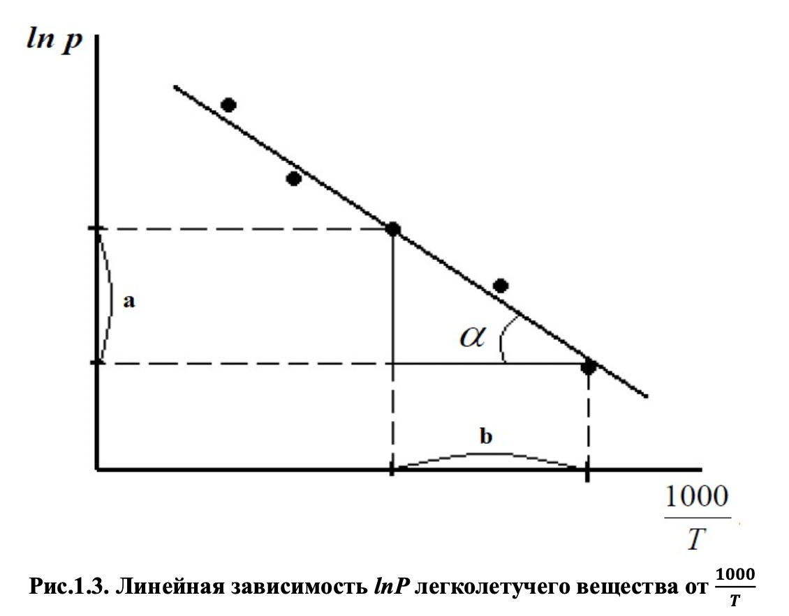
The tangent of the angle of inclination of a straight line is calculated as the ratio of the length of the opposite leg (a) to the length of the adjacent leg (b), taken in absolute values according to the scale of the resulting graph in Figure 1.3:
∆(𝒍 𝒏 𝑷)/ ∆ 𝟏𝟎𝟎𝟎/T = 𝒂 /b(1.20)

After integrating equation (1.16) in the range from 𝑃1 to 𝑃 2 and from T1 to T2:

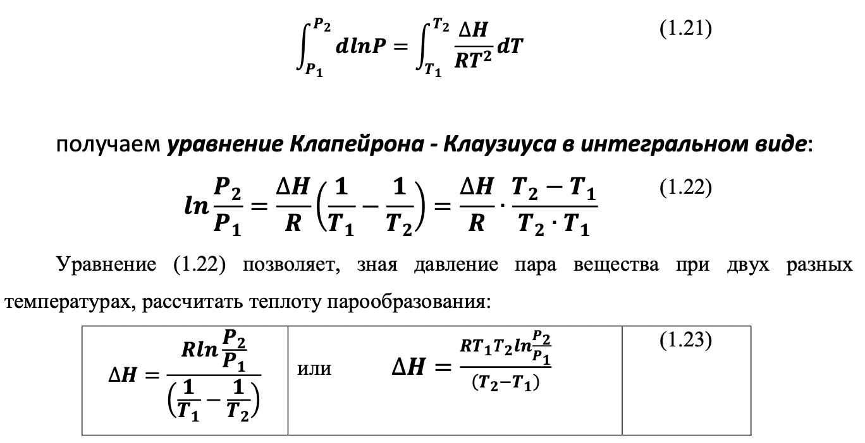

This method of determining the heat of the phase transition is called analytical.
The most crude assumption of the three that we have accepted when deriving equation (1.16)
is the assumption of the independence of ∆ 𝐻 from temperature. However, taking into account that at low pressures the heat of vaporization does not depend much on temperature, in the first
approximation it can be assumed that ∆ 𝐻 is a constant value and does not
differ much from the value of ∆ 𝐻 298* under standard conditions (P = 1 atm and T = 298 K).
This inaccuracy can be eliminated by using the Kirchhoff equation:

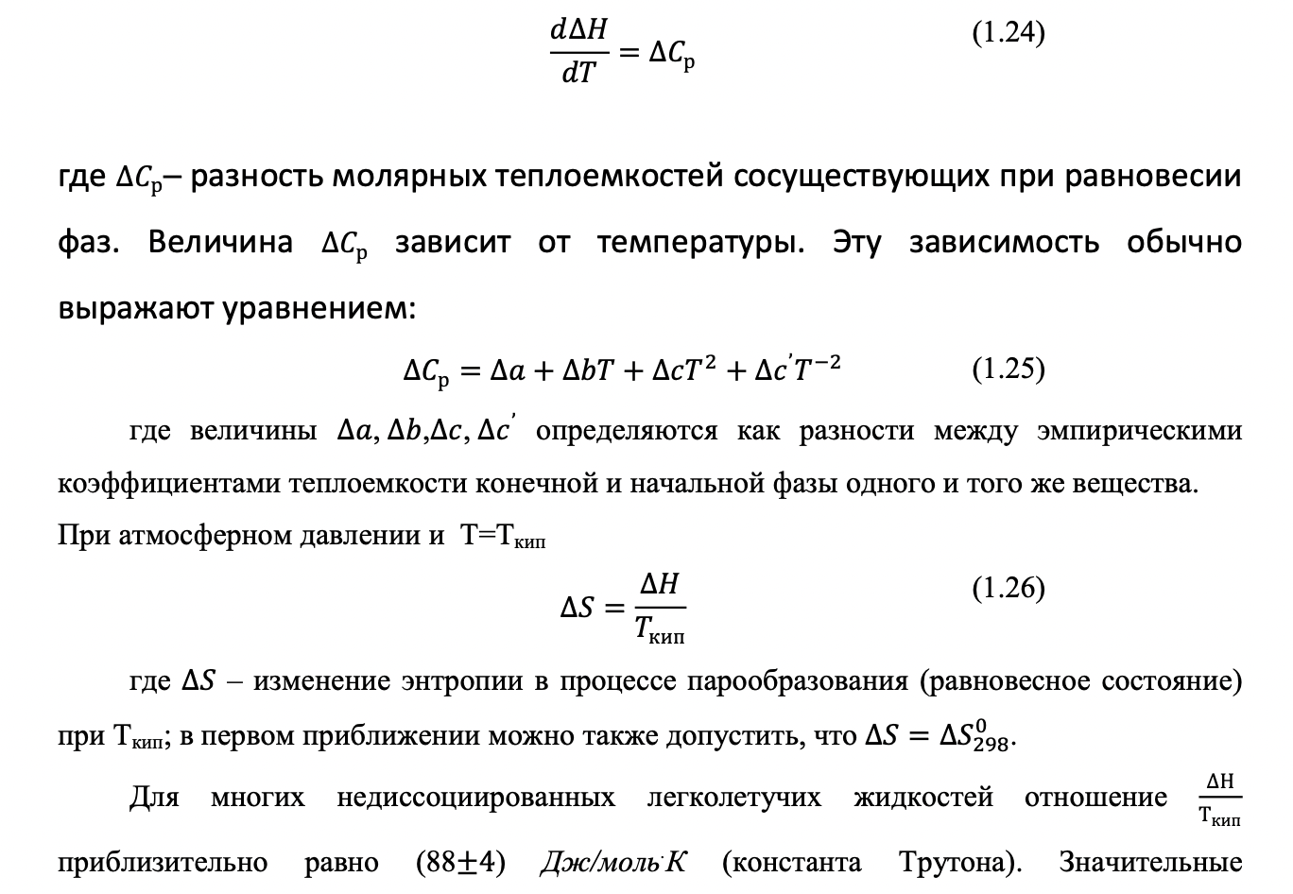положительные отклонения от этой величины указывают на заметную ассоциацию молекул.

The experimental part
Determination of the heat of vaporization of a highly volatile liquid
Objectives of the work:
1. To study the dependence of the saturated vapor pressure of a volatile liquid on the temperature.
2. Calculate the heat of vaporization of a volatile liquid based on experimental data in a graphical and analytical way.
3. Calculate the change in entropy during the evaporation of the liquid under study.

Description of the laboratory installation
The scheme of the installation for determining the pressure of saturated vapor of volatile liquids is shown in Fig.1.4.
A highly volatile liquid (water, ethanol, propanol, etc.) is poured into the vessel 1. The vessel is equipped with a return refrigerator 2 for condensation of the generated vapors and a thermometer 3. The thermometer must be located above the surface of the liquid. To avoid overheating of the liquid, glass capillaries are placed in the vessel 1. The vessel 1 is placed in a glass of water 4, heated by an electric stove 8. The reverse refrigerator 2 is communicated on the one hand with a vacuum meter 5, and on the other hand through a tap 7 with a Komovsky pump 6, with which a vacuum is created in the vessel 1.

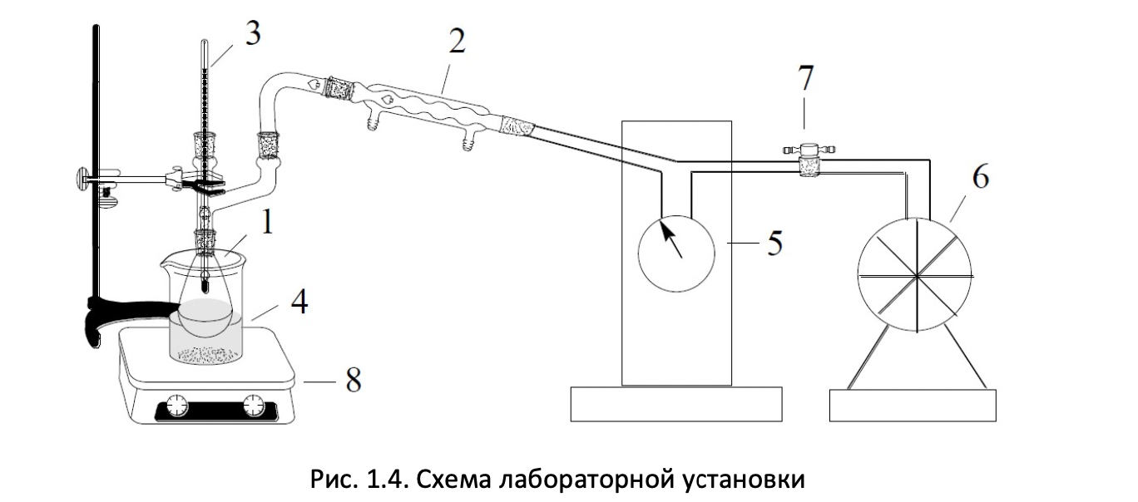
The methodology of the work
In an open vessel, the liquid boils when the saturated vapor pressure becomes equal to atmospheric pressure. If you partially pump out the air from a closed vessel containing a liquid, then there is a decrease in the boiling point to such at the level at which the saturated vapor pressure is equal to the air pressure inside the vessel. One of the methods for determining the saturated vapor pressure of the liquid under study is based on this principle. The essence of the method is that the experimenter records the boiling points of the liquid at different pressures. The pressure value inside the vessel (system) is determined using a vacuum gauge.
It is advisable to carry out measurements, moving from the maximum rarefaction to the minimum rarefaction in the system.
Before starting work, it is necessary to check the presence of liquid and capillaries in the vessel 1. Turn on the electric stove, put a glass of water on it for heating.
The first stage of the work is to check the tightness of the system. To do this, the crane 7 is placed in a position where the installation communicates with the Komovsky pump.
With the help of a pump, a maximum vacuum is created in the system so that the needle of the vacuum meter occupies a position in the range from 0.9 to 1.0.
After that, the valve 7 is closed and thereby isolates the system from the pump and the external environment. The tightness of the system is checked within 5-10 minutes. If during this time the needle of the vacuum meter does not change its position, then it is considered that the tightness of the system is ensured.
At the second stage of work, the vacuum in the system is set so that the vacuum meter shows a value in the range from 0.95 to 1.0. By this time, the water in the glass should be heated. A vessel 1 with the test liquid is lowered into a glass of heated water.
As soon as the liquid in the vessel boils, the boiling point and the vacuum meter readings are noted (equilibrium is established in the system, i.e. the boiling point and the vacuum meter readings will take constant values). The boiling point readings and the vacuum meter readings should refer to the same time point. Then the vessel 1 is lifted from the glass with water in order to stop the boiling and evaporation of the test liquid from the vessel.
After the first determination of the boiling point of the liquid, the pressure in the system is increased by about 0.1 divisions of the vacuum meter by carefully moving the tap 7 for a short period of time to the position at which air enters the system. Another way is to create a new pressure using the Komovsky pump after the tap 7 is fully opened. The boiling point is again determined at a new pressure.
The measurements are repeated until the pressure in the vessel reaches atmospheric pressure (the position of the arrow of the vacuum meter is 0). It is necessary to carry out 8-10 such measurements at different values of α (from 0.95 to 0).
All measurement results are summarized in Table 1.1.

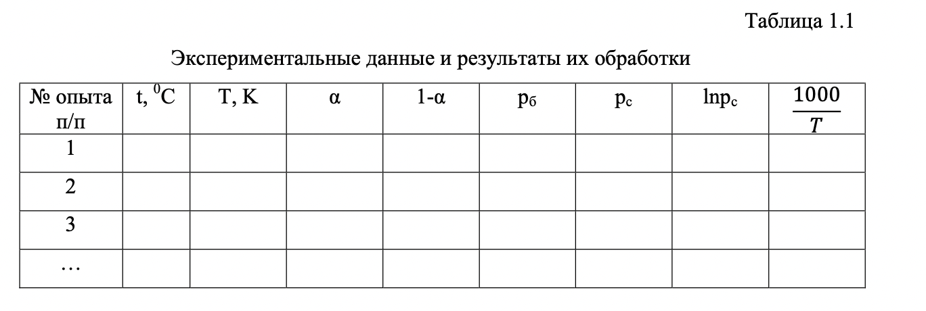
The following designations are used in Table 1.1:

α - the readings of the vacuum meter arrow;

pc- is the saturated vapor pressure of the liquid under study in the system at a given temperature;

rb - barometric (external atmospheric) pressure, which is determined by a barometer in the preparation room (for example, 740 mm pt ct);.
The pressures of rs and rb can be expressed in mmHg or in 5 Pa. For the translation of one of the other units, it is assumed that: 1atm.=760mm. Hg=1.013×10 Pa. The saturated vapor pressure of the liquid under study is calculated by the formula

p𝒄 = rb(𝟏 − 𝜶) (1.27)
For example, if the barometric pressure b p = 740 mmHg, and the arrow readings
vacuum meter α=0.5, then: p𝒄 = rb(𝟏 − 𝜶)=740∙ (𝟏 − 𝟎, 𝟓) = 𝟑𝟕𝟎 mm pt ct

On the basis of the experimental data obtained, it is necessary to do the following:
1) plot the dependence of the vapor pressure of the liquid under study on the temperature pc = 𝑓(𝑇)
2) build a graph of the dependence of ln pc =f(1000/T);
3) calculate the heat of vaporization of a liquid by a graphical method using equations (1.19) and (1.20);
4) calculate the heat of vaporization analytically by the Clapeyron-Clausius equation, using the formula (1.23);
5) compare the heat of vaporization obtained by two methods with its reference value under standard conditions (see Table 1.2);
6) calculate the change in entropy during evaporation of 1 mol of the liquid under study at the boiling point at atmospheric pressure and compare it with the table value under standard conditions (see Table 1.2);
7) analyze the results obtained and draw conclusions on the work.

